AD23532 – PRINCIPLES OF DATA SCIENCE
EXPERIMENT 3: MODEL PLANNING AND BUILDING – REGRESSION

QUESTION:
A marketing agency wants to help a retail company optimize its advertising budget. The company invests in TV, Radio, and Newspaper advertising and wants to understand how these expenditures influence product sales. Build and compare Linear Regression, Polynomial Regression, and Support Vector Regression (SVR) models to predict sales, evaluate their performance using regression metrics, and provide recommendations for optimizing the advertising budget.

AIM:
To build and evaluate Linear Regression, Polynomial Regression, and Support Vector Regression models using the Advertising dataset, analyze relationships between advertising expenditure and sales, compare model performance using MAE, MSE, RMSE, and R² score, visualize actual versus predicted sales, and recommend suitable advertising budget strategies.

ALGORITHM:
- Import the required Python libraries: Pandas, NumPy, Matplotlib, Seaborn, and Scikit-learn.
- Load the Advertising dataset into a Pandas DataFrame and display the first and last records, dataset shape, data types, missing values, duplicate records, and summary statistics.
- Select TV, Radio, and Newspaper as input features (X) and Sales as the target variable (y).
- Generate pair plots and a correlation heatmap to identify relationships between advertising expenditure and sales.
- Split the dataset into 80% training data and 20% testing data.
- Train a Linear Regression model and predict sales on the test dataset.
- Train a Polynomial Regression model of degree 2 and predict sales on the test dataset.
- Train a Support Vector Regression model using the RBF kernel and predict sales on the test dataset.
- Evaluate all three models using MAE, MSE, RMSE, and R² score.
- Compare model performance using a grouped bar chart and plot actual versus predicted sales for the best-performing model.
- Identify the model with the lowest prediction error and suggest three recommendations for optimizing the advertising budget.
PROGRAM & OUTPUT:
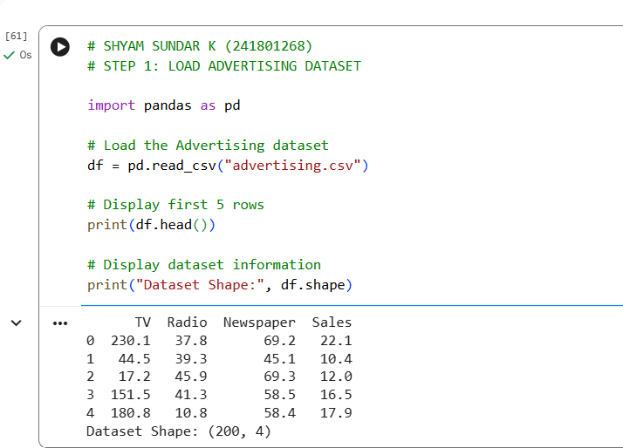
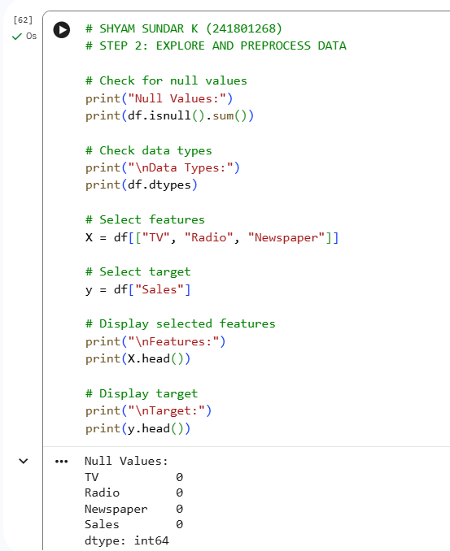
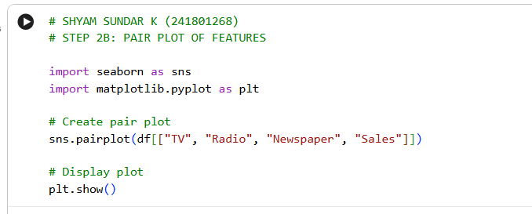
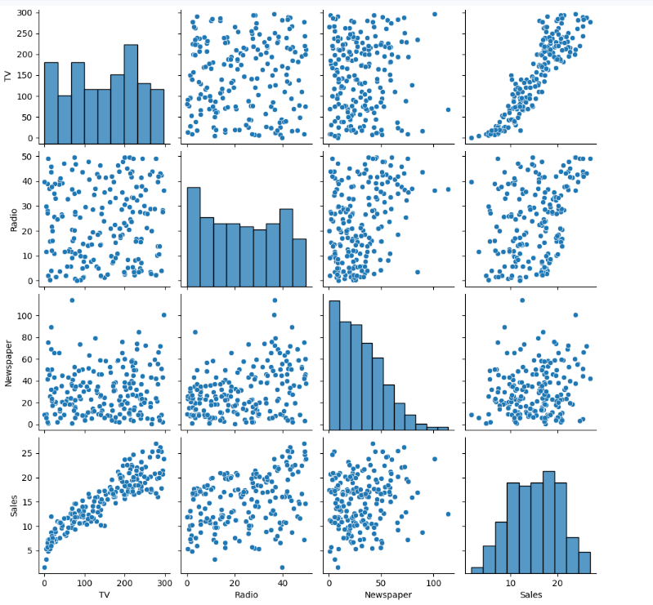
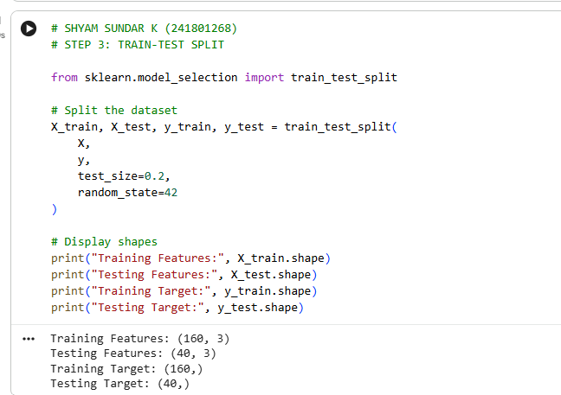
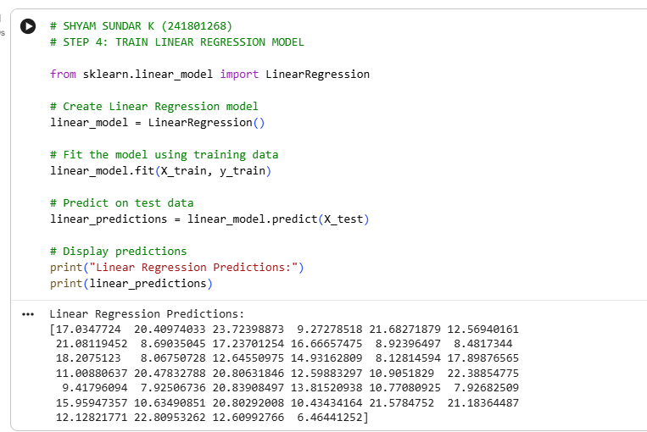
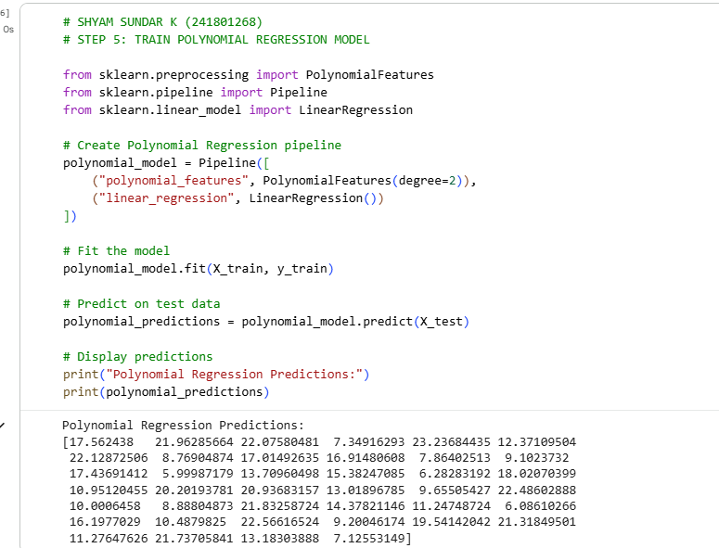
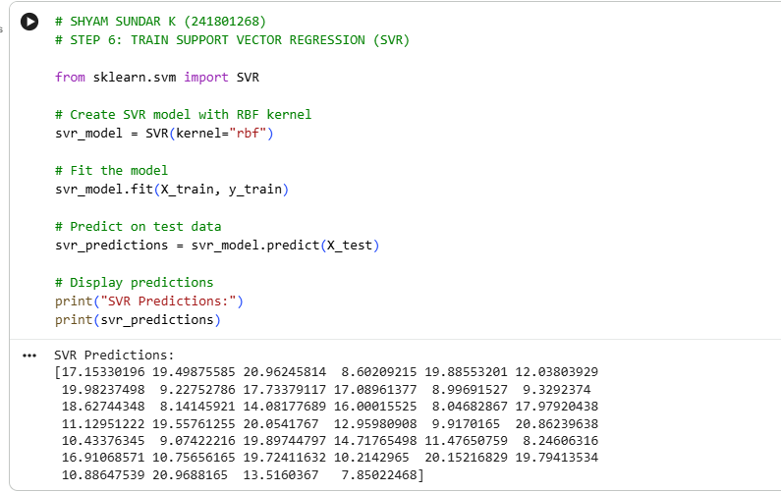
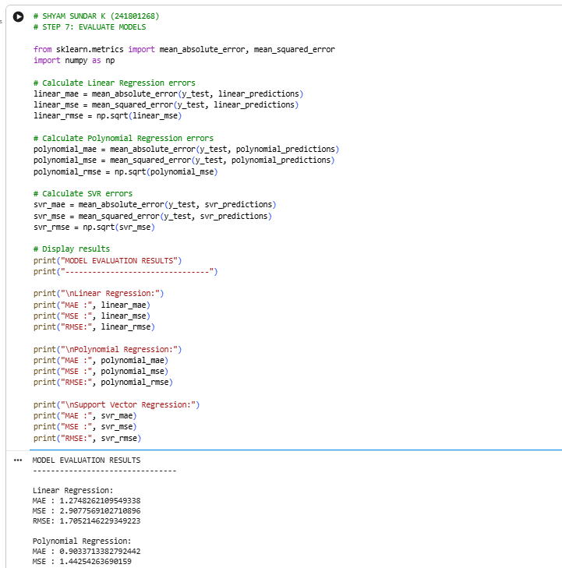
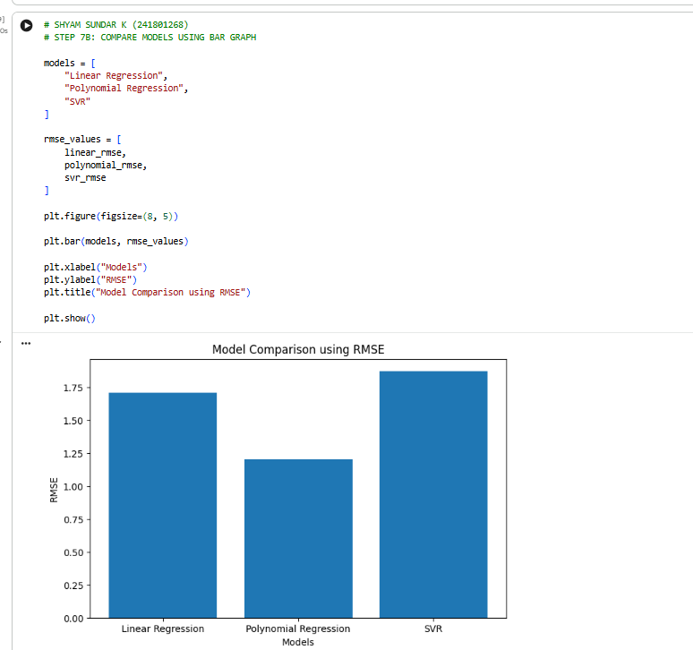
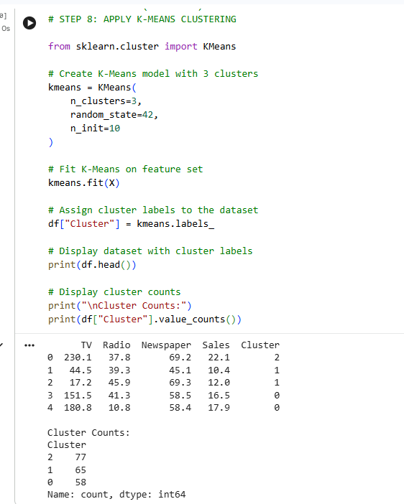
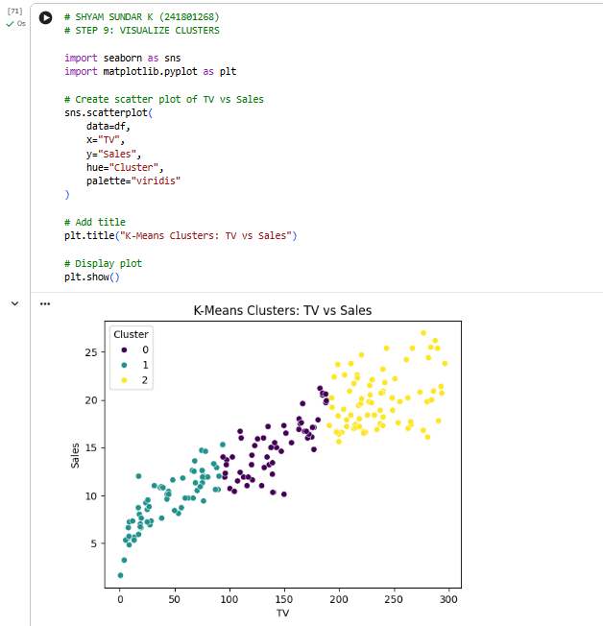

RESULT:
Thus, Linear Regression, Polynomial Regression, and Support Vector Regression models were successfully built and evaluated using the Advertising dataset. Their performance was compared using MAE, MSE, RMSE, and R² score. The best-performing model was identified based on the lowest RMSE, and actual versus predicted sales were visualized. Recommendations were provided to help optimize advertising expenditure and improve sales forecasting.

